To Update insert access vendor id

Ticket: #000000247546229

This WA is to add new record in access_vendor table.

Use below query to get info…

insert into access_vendor(access_vendor_id, vendor_name, avail_ind, vendor_type, new_vendor_name, vendor_abbrev, country_code, icore_vendor_id, icore_vendor_name, stacking_ind, instar_vendor_name, accu_tie_down_ind, fdd_ind) values (475, 'PLANTERS COMM','Y',0,'PLANTERS COMM','PLNT','US',8563,'PLNT','Y','PLANTERS COMM','N','N')

now before doing insert query we need to check the previous access_vendor_id, so we can add new id respectively.

Use below query to check the previous or last used access_vendor_id.

select * from access_vendor order by access_vendor_id desc

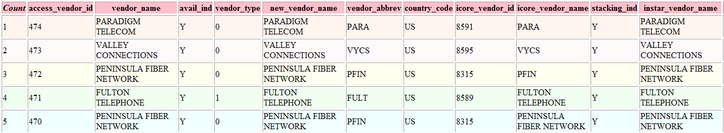

Here access_vendor_id is 474 so it means next entry in insert should be 475.